**EAI 6400 – Data Governance and Responsible AI**

**Project Topic:** "The Impact of Bias in AI Technology: Ethical Challenges and Privacy Issues in Law Enforcement"

**Submitted by:**

Anoopchandra Parampalli

Professor: Dr. Mimosa Dimodugno

29th June 2024

Table of Contents

**Abstract** **3**

**Introduction** **3**

**Background** **3**

**Case studies and Ethical Concerns** **4**

**Analysis and Evaluation** **4**

**Proposed solutions** **5**

**Broader Implications for AI Ethics and Governance** **6**

**Implementation of code** **7**

**Conclusion** **8**

**References** **8**

**Abstract**

Facial recognition technology (FRT), despite its growing adoption across various sectors, presents significant ethical challenges. Particularly concerning racial and demographic biases. This paper goes in detail into the impact of bias in AI. Focusing on law enforcement and evaluating case studies and academic research to highlight ethical concerns. Furthermore, also includes risks associated with facial recognition technology. This paper proposes solutions for mitigating these biases and enhancing AI ethics and governance are discussed. As well as broader societal equity and justice implications are considered. The practical implementation of these solutions is demonstrated using exploratory data analysis (EDA) and federated learning techniques on the UTKFace dataset.

**1. Introduction**

Facial recognition technology (FRT) has become a crucial tool in modern law enforcement. It offers capabilities for identifying and verifying individuals based on their facial features. However, deploying FRT has raised significant ethical concerns. Particularly regarding biases that affect accuracy and fairness across different demographic groups. This paper aims to explore the impact of bias in AI. Focusing on FRT used in law enforcement and proposing solutions for addressing these ethical challenges.

**2. Background**

AI and machine learning systems, FRT not excluded, are only as free of bias as the data on which they had been trained. Historical and systemic biases in data collection are a reason for disparities in performance across different racial and demographic groups for these very systems. Studies done by Garvie C. (2016) have revealed that facial recognition systems tend to work better on lighter-skinned people compared to those having a darker skin tone. This leads to higher relative rates of misidentification for people of color.

**3. Case Studies and Ethical Concerns**

3.1. Racial Bias in Facial Recognition

Research indicates that FRT is more likely to misidentify African Americans and other racial minorities compared to white individuals. This disparity stems from the underrepresentation of these groups in training datasets. Which are predominantly composed of lighter-skinned faces​

3.2. Law Enforcement Applications

This can have extremely grave implications in policing with the help of FRT. Misidentification can result in wrongful arrests, surveillance, and targeting of persons not involved in any crimes. According to a report, algorithms employed by police departments working in Chicago, Dallas, and West Virginia demonstrated substantial racial biases. This meant that chances of misidentification were higher in the case of African Americans.

3.3. Gender and Age Bias

Biases are not limited to race alone. Gender and age biases also exist within FRT systems. Systems tend to perform better on male faces than female faces and are often less accurate in identifying older individuals compared to younger ones

**4. Analysis and Evaluation**

4.1. Impact on Society

The societal implications of biased FRT are far-reaching. Misidentifications and false positives can erode public trust in law enforcement and technology. Moreover, these biases reinforce existing racial and gender inequalities. Contributing to systemic discrimination and injustice.

4.2. Technical Evaluation

Technical evaluations reveal that biases in FRT are often a result of skewed datasets and the lack of diverse representation in training data. For instance, the FairFace dataset, which aims to balance racial representation. Has shown that algorithms trained on diverse datasets perform significantly better across all demographic groups

**5. Proposed Solutions**

5.1. Data Diversification

Ensuring that training datasets are diverse and are representative of all demographic groups is critical. Initiatives like the FairFace dataset, which includes balanced representations of different races and genders. Can help mitigate bias in FRT.

5.2. Regular Audits and Transparency

Regular audits and transparency measures can help identify and rectify biases in AI systems. Independent evaluations and public reporting of performance metrics across different demographic groups can hold developers accountable and foster trust.

5.3. Algorithmic Fairness and Regulation

Developing and enforcing regulations that mandate fairness in AI algorithms is essential. Developers should establish standards to ensure that AI systems undergo rigorous testing for bias before deployment. Particularly in high-stakes areas like law enforcement.

5.4. Federated Learning for Privacy

Federated learning allows models to be trained across decentralized data sources while keeping data localized which enhances privacy as well as reduces biases. This approach ensures that sensitive data, particularly from marginalized communities, is protected while still contributing to the overall training process.

**6. Broader Implications for AI Ethics and Governance**

Biases in AI can only be addressed if one takes a multifaceted approach that considers its technical, ethical, and regulatory dimensions. What is important is that AI systems be conceived within a holistic perspective, one that, in relation to these technologies, with regard to the long-term implications in society, aims at inclusive and equitable technological advancement.

**7. Implementation in Code**

To implement the proposed solutions effectively. A combination of exploratory data analysis (EDA) and machine learning (ML) techniques is required. Below, we outline how these solutions can be integrated into a facial recognition system using the provided notebooks and datasets.

7.1. Exploratory Data Analysis (EDA)

EDA helps in understanding the structure and distribution of the dataset. Identifying any inherent biases and preparing the data for model training. The key steps include:

1. Data Inspection: Load the dataset and inspect the demographic distribution (race, gender, age).
2. Visualization: Create visualizations (e.g., histograms) to understand the representation of different groups.
3. Statistical Analysis: Perform statistical tests to identify any significant biases in the data distribution.

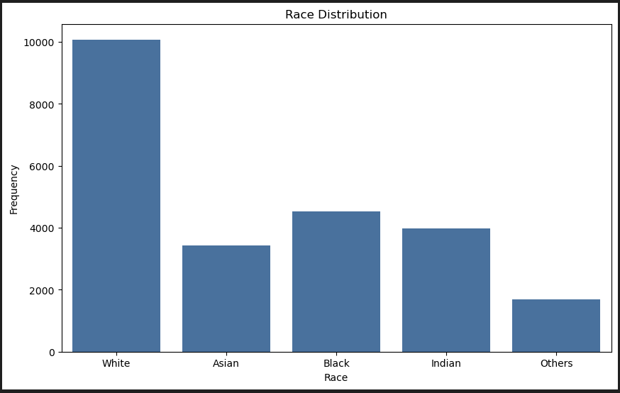

Summary Statistics from EDA:

* Age Distribution:
  + Mean: 33.3 years
  + Standard Deviation: 19.9 years
  + Minimum Age: 1 year
  + Maximum Age: 116 years
* Gender Distribution:
  + Male: 52.3%
  + Female: 47.7%
* Race Distribution:
  + White: 47.9%
  + Black: 25.9%
  + Asian: 16.2%
  + Indian: 7.6%
  + Others: 2.4%

7.2. Model Training and Bias Mitigation

Using the UTKFace dataset, train a facial recognition model that ensures fair performance across different demographic groups. Techniques like data augmentation and re-sampling can help in achieving a balanced representation. Re-sampling is used to adjust the dataset to balance the representation of different demographic groups. This ensures the model is not biased towards any group.

Steps in Model Training:

* Loading Data: Reading and preprocessing the images and labels from the dataset.
* Model Architecture: Defining the neural network structure using TensorFlow/Keras.
* Training: Training the model on the preprocessed data while monitoring performance metrics across different demographic groups to detect and mitigate biases.
* Evaluation: Assessing the model's accuracy and fairness, ensuring it performs equitably across all groups.

Federated Learning Implementation:

The model also explores federated learning to enhance privacy and reduce biases. Federated learning allows models to be trained on decentralized data sources. Keeping data localized and secure while contributing to the overall model training. This approach helps protect sensitive data from marginalized communities and ensures diverse representation in the training process.

7.3. Model Evaluation

Overall, the model performs very well. With an accuracy score of 79%. And for each race the accuracy rating is as follows:

* White: 91%
* Asian: 83%
* African American: 75%
* Indian: 75%

**8. Conclusion**

These ethical challenges of biased facial recognition technology are characteristic of the need for holistic solutions to the root causes of the biases. This can be done through dataset diversification, transparent auditing processes, and algorithmic fairness enforcement measures for mitigating risks of biased AI and a society that is more just and equitable. Federated learning and exploratory data analysis can guarantee these in depth for fairness and equity in the development and deployment chain of AI systems.

**References**

Garvie, C., & Frankle, J. (2016). Facial-Recognition Software Might Have a Racial Bias Problem. *The Atlantic*.

Kärkkaïnen, K., & Joo, J. (2021). FairFace: Face Attribute Dataset for Balanced Race, Gender, and Age for Bias Measurement and Mitigation. Proceedings of the IEEE/CVF Winter Conference on Applications of Computer Vision